CASE STUDY PYSPARK (2-08-2025)

from pyspark.sql import SparkSession
from pyspark.sql.functions import col, count, max as max_, min as min_, sum as sum_

# Start Spark session
spark = SparkSession.builder.appName("Online Banking Analysis").getOrCreate()

# Load datasets
loan_df = spark.read.csv("/content/loan.csv", header=True, inferSchema=True)
credit_df = spark.read.csv("/content/credit card.csv", header=True, inferSchema=True)
txn_df = spark.read.csv("/content/txn.csv", header=True, inferSchema=True)

# Show schema just to verify
loan_df.printSchema()
credit_df.printSchema()
txn_df.printSchema()
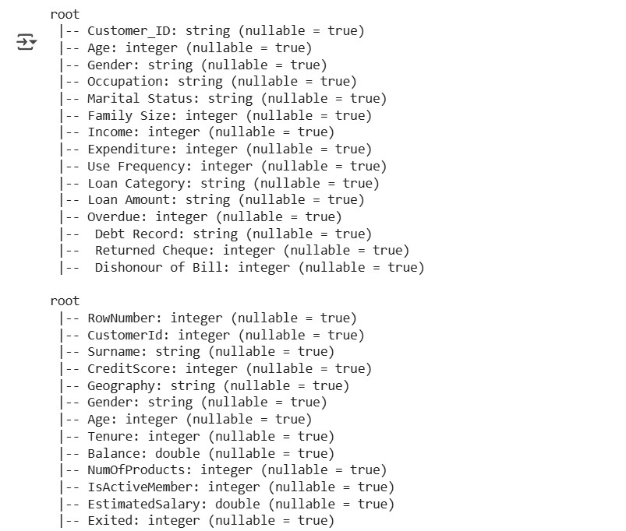
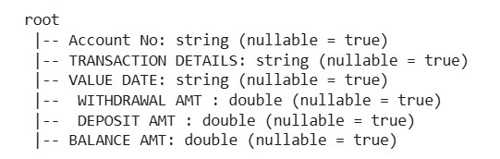

#show tables
loan_df.show(5)
credit_df.show(5)
txn_df.show(5)
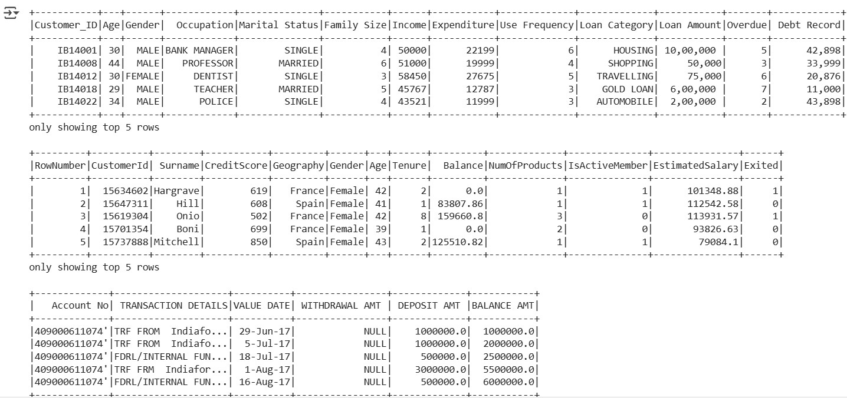

#Loan data use cases
print("\n# Number of loans in each category:")
loan_df.groupBy("Loan_Category").count().show()
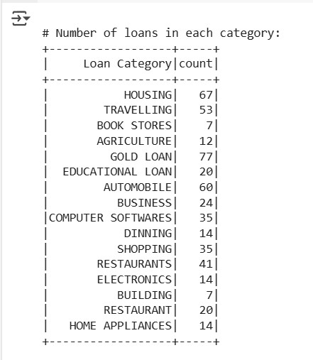
print("\n# Number of people who have taken more than 1 lakh loan:")
loan_df.filter(col("Loan_Amount") > 100000).select("Customer_ID").distinct().count()
output:
# Number of people who have taken more than 1 lakh loan:
0
print("\n# Number of people with income greater than 60000 rupees:")
loan_df.filter(col("Income") > 60000).select("Customer_ID").distinct().count()
output:
# Number of people with income greater than 60000 rupees:
198
print("\n# Number of people with 2 or more returned cheques and income less than 50000:")
loan_df.filter((col("Returned_Cheques") >= 2) & (col("Income") < 50000)).select("Customer_ID").distinct().count()
output
# Number of people with 2 or more returned cheques and income less than 50000:
136
print("\n# Number of people with 2 or more returned cheques and are single:")
loan_df.filter((col("Returned_Cheques") >= 2) & (col("Marital_Status") == "Single")).select("Customer_ID").distinct().count()
output:
# Number of people with 2 or more returned cheques and are single: 0
print("\n# Number of people with expenditure over 50000 a month:")
loan_df.filter(col("Monthly_Expenditure") > 50000).select("Customer_ID").distinct().count()
output:
# Number of people with expenditure over 50000 a month:
6
print("\n# Number of members who are eligible for credit card:")
loan_df.filter(col("Eligible_for_CreditCard") == "Yes").select("Customer_ID").distinct().count()
output:
# Number of members likely eligible for credit card (Income > 50k, Returned Cheque = 0):
22

# CREDIT CARD DATA USE CASES

print("\n# Credit card users in Spain:")
credit_df.filter(col("Country") == "Spain").select("Customer_ID").distinct().count()
output:
# Credit card users in Spain:
2477

print("\n# Number of members who are eligible and active in the bank:")
credit_df.filter((col("Eligible") == "Yes") & (col("Status") == "Active")).select("Customer_ID").distinct().count()
output:
# Number of members who are likely eligible (CreditScore > 650) and active in the bank:
2655

#TRANSACTION DATA USE CASES
from pyspark.sql.functions import col, max as max_, min as min_, sum as sum_, to_date

# Step 1: Clean all column names (remove leading/trailing spaces and replace internal spaces with "_")
txn_df = txn_df.toDF(*[c.strip().replace(" ", "_") for c in txn_df.columns])

# Step 2: Cast numeric fields and parse date
txn_df = txn_df.withColumn("WITHDRAWAL_AMT", col("WITHDRAWAL_AMT").cast("double")) \
.withColumn("DEPOSIT_AMT", col("DEPOSIT_AMT").cast("double")) \
.withColumn("BALANCE_AMT", col("BALANCE_AMT").cast("double")) \
.withColumn("VALUE_DATE", to_date("VALUE_DATE", "dd-MM-yyyy"))
print("\n# Maximum withdrawal amount in transactions:")
txn_df.select(max_("WITHDRAWAL_AMT").alias("Max_Withdrawal")).show()
output:
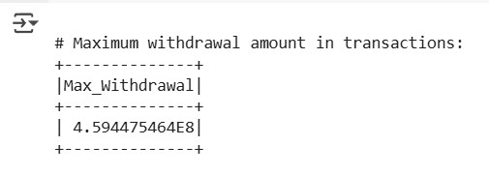
print("\n# Minimum withdrawal amount in transactions:")
txn_df.select(min_("WITHDRAWAL_AMT").alias("Min_Withdrawal")).show()
output:
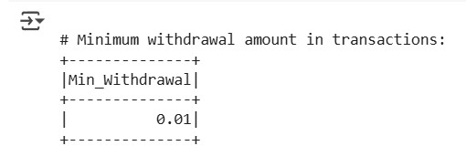
print("\n# Maximum deposit amount in transactions:")
txn_df.select(max_("DEPOSIT_AMT").alias("Max_Deposit")).show()
output:
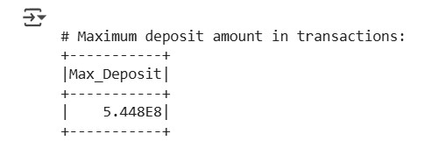
print("\n# Minimum deposit amount in transactions:")
txn_df.select(min_("DEPOSIT_AMT").alias("Min_Deposit")).show()
output:
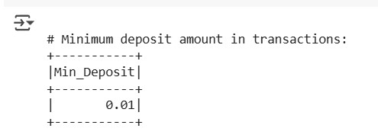
print("\n# Sum of balance in every bank account:")
txn_df.groupBy("Account_No").agg(sum_("BALANCE_AMT").alias("Total_Balance")).show()
output:
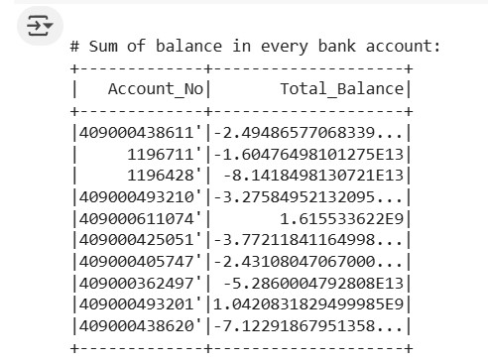
print("\n# Number of transactions on each date:")
txn_df.groupBy("VALUE_DATE").count().orderBy("VALUE_DATE").show()
output:
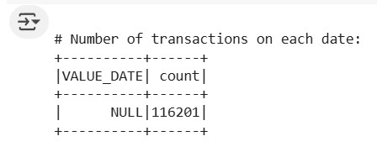
print("\n# List of accounts with withdrawal amount more than 1 lakh:")
txn_df.filter(col("WITHDRAWAL_AMT") > 100000) \
.select("Account_No", "WITHDRAWAL_AMT").distinct().show()
Output:
